Guyana Energy Agency Art Competition 2020

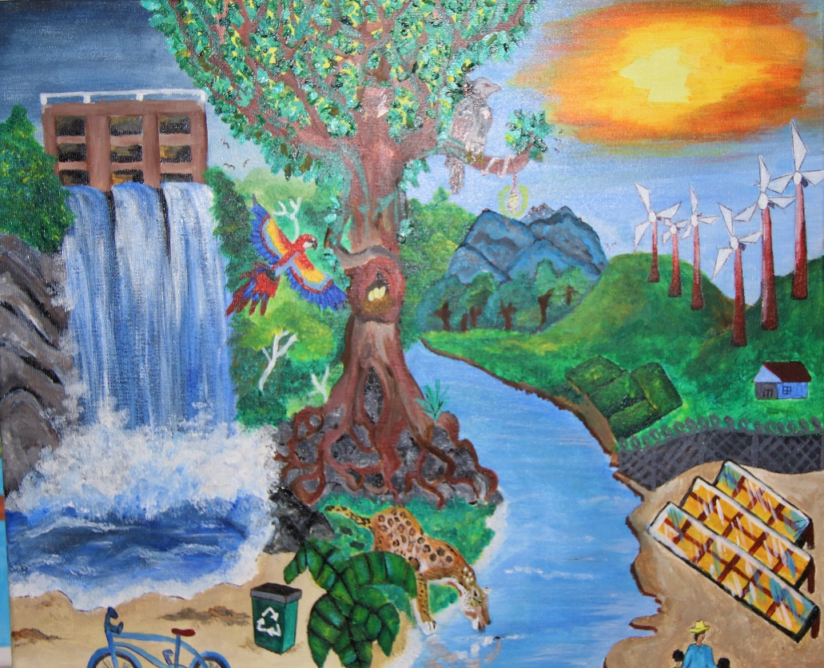

A) Overview
Sustainable energy is an important aspect of a low-carbon economy. Guyana has embarked on a green path in keeping with the ‘Green State Development Strategy -Vision 2040’. Renewable energy and energy efficiency, the two pillars of sustainable energy, are not only essential for energy diversification and energy security, but also climate change mitigation and overall sustainability.
To this end, the Guyana Energy Agency (GEA), as part of its ‘Energy Awareness’ activities for 2020, is launching an Art Competition for youth between the ages of 15-19 under the theme: ‘My Vision for a Smart City/Town in Guyana in the Year 2040’. The artist will be required to choose a part of an actual city/town in Guyana to depict/illustrate their vision of a modern, smart, green, low carbon, sustainable future.
This art competition is organized in an effort to sensitize youth about energy use, environmental issues and sustainable development and their inextricable links, not only to energy security at a national level, but also its impact on nature and the environment. It also aims to facilitate discussions on such topics among students and teachers with encouraged learning throughout the process. Additionally, the Agency is seeking to acquire innovative designs that may be used to further promote its cause and educate the general Guyanese public about alternative energy and energy conservation.
Submitted pieces should be creative and additional points will be awarded for the inclusion of special Land Marks and buildings within the Town/City of choice.

Guidelines For Art Competition
B) Target Participants
Youth between the ages of 15-19.
C) TOPIC/THEME
Theme: ‘My Vision for a Smart City/Town in Guyana in the Year 2040’.
The artist will be required to choose a part of an actual city/town in Guyana to depict/illustrate their vision of a modern, smart, green, low carbon, sustainable future.

D) General Guidelines for Activity
- The competition is open only to persons who fall within the specified age range.
- Submitted entries must have a maximum dimension of 18x24 inches.
- Submitted pieces MUST incorporate elements of renewable energy and MUST be accompanied with information pertaining to name, age, class, school (if attending any), phone number, title and a brief description of artwork.
- Entries missing any of the above information will not be considered.
- Artwork must be submitted in hard copy format (canvas, cardboard, paper, etc.)
- Accepted artwork must be the original, unpublished creation of the submitting person. Up to one entry may be submitted per person.
- Adult, obscene, offensive, or otherwise indecent artwork is strictly forbidden. Submission of your artwork acknowledges that your design could be used by the Guyana Energy Agency for promotional purposes.
- The Judges’ decision is final.
E) Submission
The submission date for this competition has been extended. The new deadline for submission is on or before Friday 28th, August 2020 at 3:30 pm.
Entries should be submitted to Mrs. Taiwo Williams or Ms. Shevon Wood at the following address:
ENERGY AND ENERGY STATISTICS DIVISION
GUYANA ENERGY AGENCY
295 Quamina Street,
South Cummingsburg, Georgetown
Telephone No.: 225-8569 ext. 211 0r 236Z

F) Prizes
Prizes and trophies will be awarded to first, second and third place entries in November as part of our activities to commemorate ‘Energy Month’ 2020. These are as follows:
1st Place: $75,000 + plaque
2nd Place: $55,000 + plaque
3rd Place: $40,000 + plaque
Also, the representative schools (if winner is attending) of the first, second and third place winners will be awarded a trophy.

JUDGING CRITERIA

The following will be taken into consideration when judging the submitted pieces:

Originality:
Consider: Exhibits creativity

Message Content:
Consider: message/artwork reflection of theme (relevance)

Craftsmanship:
Consider: Artist’s skill in the use of material (s)

Elements of Art:
Consider: Line, color, space, form, balance, media and texture

Composition:
Consider: Effective use of forms or abstract techniques

Unity and Variety:
Consider: Balance of elements, repetition, visual rhythm

Medium and Texture:
Consider: Appropriate use of materials and textures

Use of space:
Consider: Perspective and mass

Presentation:
Consider: Appearance, neatness, complimentary framing and/or mounting

Degree of Difficulty:
Consider: Appropriate for artist’s maturity and ability

