D5. Identify environmental and social risks and prepare Environmental and Social Management Plans

Consulting Services for the Preparation of Detailed Designs and Technical Specifications for Energy Efficiency Measures and Distributed Solar PV Systems for Public Buildings in Guyana.

LC-OECS COMMISSION-414663-CS-QCBS, LOT 3 GUYANA



Reference: S00289
“This report is produced for the OECS Commission as part of the Project Preparation Activities of the Caribbean Efficient and Green-Energy Buildings with funding from the World Bank.”
Barcelona, 30th September 2025

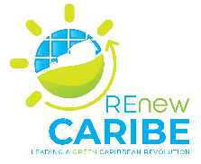

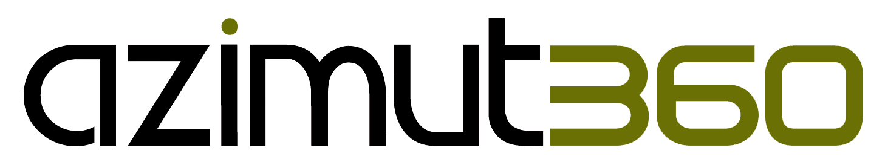

Table of Contents
Revisions 5
List of abbreviations 6
1 Introduction 7
2 Description of the Project 9
3 Environmental and Social Baseline 12
Zeeburg Secondary School 12
West Ruimveldt Primary School 14
Good Hope Secondary School 15
Yarrowkabra Secondary School 17
4 Environmental and Social Management Plan 19
4.1 Implementation Arrangements and Reporting 33
4.2 Institutional Strengthening and Capacity Building 39
4.3 Grievance Redress Mechanism 40
4.3.1 Stakeholder Engagement 41
4.3.2 Cost 43
Annex 45
Grievance Redress Forms 45

List of Tables
Table 1: Project locations for EE and DPV Interventions in Guyana 7
Table 3: Demographics and Social Characteristics 13
Table 4: Social Baseline Indicators 13
Table 5: Demographic and Social Characteristics 15
Table 6: Social Baseline Indicators 15
Table 7: Demographic and Social characteristics 16
Table 8: Social Baseline Indicators 17
Table 9: Demographic and Social Characteristics 18
Table 10: Social Baseline Indicators 18
Table 11: Results of the Environmental and Social Screening of the educational institutions 19
Table 12: Risk Assessment Matrix 21
Table 13: Identification of impacts on the Educational Institutions 22
Table 14: Mitigation and Monitoring Arrangements for Educational Institutions 29
Table 15: Training Plan 39
Table 16: Grievance Submission Form 45
Table 17: Grievance Management Registration and Monitoring Sheet 47
Table 18: Grievance Disclosure/Release Form (Result Of Grievance Management) 48
Table 19: Stakeholders’, Interests, and Needs 41
Table 20: Cost Estimates for all four institutions 44

List of Figures
Figure 1: Frontal view of Zeeburg Secondary School 11
Figure 2: Location of Zeeburg Secondary School 12
Figure 3: Frontal view of West Ruimveldt Primary School 13
Figure 4: Location of West Ruimveldt Primary School 13
Figure 5: Frontal view of Good Hope Secondary School 14
Figure 6: Location of Good Hope Secondary School 15
Figure 7: Frontal view of the Yarrowkabra Secondary School 16
Figure 8: Location of Yarrowkabra Secondary School 16
Figure 9: Organisational Structure of the Project Implementing Unit 32
Figure 10: Institutional Capacity Structure for Maintenance and Operations 34

Revisions

Document Version | Checking Date | Checked by | Comments
V 0.0 | 02/06/2025 | AIGUASOL | Formatting and alignment, content development, attention to quality, timeline
V0.1 | 12/08/2025 | AIGUASOL | Draft sent to client
V0.2 | 31/08/2025 | World Bank | ESMPs need to be more structured, concise, and consistent, with clear coverage of all sites and removal of redundant or inaccurate content.  Screening checklists, risk assessments, and clear assignment of responsibilities (contractor/institution) must be included, along with monitoring and reporting arrangements.  Site-specific issues such as bat presence at the GRA building and potential mold/asbestos must be assessed and addressed.  Budgets are unrealistic and require review and refinement to align with actual mitigation needs.
V.03 | 9/09/2025 | World Bank | Review of Environmental and Social Mitigation measures, Contractors’ responsibilities, social aspects including Grievance Redress mechanism and Stakeholder Consultation Plan and costing justification
V.04 | 30/09/2025 | Aiguasol | Final submission

List of abbreviations
Abbreviation | Meaning
BOQ | Bill of Quantities
CEGEB | Caribbean Efficient and Green Energy Buildings
DPV | Distributed Solar Photovoltaics
DRE | Distributed Renewable Energy
EE | Energy Efficiency
EEM | Energy Efficiency Measures
ESF | Environmental and Social Framework
ESCP | Environmental and Social Commitment Plan
ESMF | Environmental and Social Management Framework
ESMP | Environmental and Social Management Plan
ESS | Environmental and Social Standards
GEA | Guyana Energy Agency
GHG | Greenhouse Gas Emissions
GLSC | Guyana Lands and Surveys Commission
GNBS | Guyana National Bureau of Standards
GPL | Guyana Power and Light Incorporated
GWI | Guyana Water Incorporated
GWP | Global-warming potential
HECI | Hinterland Electrification Company Incorporated
LCDS | Low Carbon Development Strategy
OECS | Organisation of Eastern Caribbean States
PDO | Project Development Objective
PPG | Project Preparation Grant
PV | Photovoltaics
RDC | Regional Democratic Council
RE | Renewable Energy
SOP | Series of Projects
WB | World Bank
WHO | World Health Organisation

Introduction
The Caribbean Efficient and Green Energy Buildings (CEGEB) Project will address shared challenges in the energy sector within the Caribbean. It will support investment in energy efficiency measures (EEMs) and distributed solar photovoltaics (DPV) systems. The energy efficiency (EE) retrofits will include passive and active measures along with improvements in building-control systems. Passive EE measures will incorporate energy-efficient windows, shading, wall and roof insulation, cool surfaces, etc. Active EE measures will include the replacement of existing inefficient building equipment and appliances, or installation of new energy efficient equipment and appliances, such as lighting systems, air-conditioning equipment, ceiling fans, and refrigerators or freezers using refrigerants with low or no global-warming potential (GWP), where appropriate. Improvements in control systems will include smart controls, sensors, and energy management systems to meet EE objectives. The Project will also support safe disposal of used equipment and materials. These works will be implemented at government buildings and facilities including central and municipal administrative buildings, universities and schools, hospitals and clinics, stadiums, and other publicly owned facilities. Locations are expected to be on government-owned land in urban and peri-urban settings in the countries.

Table 1: Project locations for EE and DPV Interventions in Guyana
Sub-Project Site Type | Sub-Project Site Name | Locations | Regions
Government Administrative Buildings | Regional Democratic Council | Vreed – en – hoop | Region 3
Government Administrative Buildings | Guyana Revenue Authority | Parika | Region 3
Government Administrative Buildings | Guyana Elections Commission, Head Office | Georgetown | Region 4
Educational Institutions | Good Hope Secondary School | East Coast Demerara | Region 4
Educational Institutions | West Ruimveldt Primary School | Georgetown | Region 4
Educational Institutions | Yarrowkabra Secondary School | Linden/ Soesdyke Highway | Region 4
Educational Institutions | Zeeburg Secondary School | Zeeburg | Region 3
Healthcare/storage Institutions | Parika Health Center | Parika | Region 3
Healthcare/storage Institutions | Rosignol Health Center | Rosignol | Region 5
Healthcare/storage Institutions | National Ophthalmology Hospital | Port Mourant | Region 5
Healthcare/storage Institutions | Port Mourant District Hospital | Port Mourant | Region 5
Healthcare/storage Institutions | Ministry of Health Central Supplies Unit | Water Street, Georgetown | Region 4
Healthcare/storage Institutions | Ministry of Health Materials Management Unit |  | Region 4

The objective of this assignment is to define the EEMs and DPVs and prepare the detailed design, technical specifications, and bill of quantities (BOQ) for the bidding documents for implementing the proposed EEMs and DPVs investments. The part includes identification of environmental and social risks associated with the planned implementation and preparation of Environmental and Social Management Plans (ESMPs) in accordance with the Environmental and Social Management Framework (ESMF) as well as other national environmental legislation and regulations in Guyana.

Scope of Environmental and Social Management Plan
The works under this part entail identification of environmental and social risks and preparation of an ESMP including:
- Identification of environmental and social risks associated with the implementation of the EEMs.
- Preparation of site specific ESMPs.
- Provision of support to the Guyana Energy Agency in public consultations on audit and ESMPs.

Methodology
The approach adopted were as per requirements of the World Bank and Guyana’s national legal framework. Initially, screening of the environmental and social setting and any potential environmental and social impacts and risks were assessed using the World Bank’s Environmental and Social Screening Questionnaire and the Guyana - Environmental Protection Agency’s Guidelines for Preparation of an Environment Assessment and Management Plan. Secondary data was collected based on scientific, engineering, environmental and economic parameters, professional judgement, and consultation with the relevant stakeholders.

Limitations - Interdependencies in Team Deliverables
The timely completion of this report was partially constrained by dependencies on contributions from other team members. Specifically, certain sections of Chapter 2 (Description of the EEMs and DPVs) required input or data from parallel reports that were still in progress. As a result, there were delays in accessing critical information needed to complete this report comprehensively and within the originally scheduled timeframe. This interdependence among team deliverables underscores the need for improved coordination and sequencing in future project timelines.

Description of the Project
Description of the Energy Efficient Measures and Distributed Photovoltaic Systems to be installed and key features
The optimal energy efficiency scenario for the educational institutions includes the addition of all the following proposed energy efficiency measures:
- Addition of an external insulation layer on the roof
- Replacing the windows in conditioned rooms to achieve code compliance
- Ceiling mounted fans in classrooms
- Ceiling mounted fans in conditioned rooms
- Replacing fluorescent tubes with LED lighting
- Installing occupancy detection sensors in bathrooms
- Smart switches to control the electricity consumption in appliances
- Nighttime air conditioning shutdown

Design and Technology
Addition of an external insulation layer on the roof
An insulated steel roof sandwich panel with a high-density polyurethane core, enclosed between two layers of pre-lacquered galvanized steel for enhanced thermal insulation is recommended for an added layer of external insulation. The insulation layer should be approximately 160 mm of mineral wool or 80 mm of polyurethane, depending on the desired thermal conductivity.
The panel proposed for the external insulation layer is an insulated steel roof sandwich panel featuring a mineral wool core for thermal insulation, encased between two layers of pre-lacquered galvanized steel. It is available in 160 mm thickness, ensuring optimal sealing and reduced thermal losses.

Replacing the windows in conditioned rooms to achieve code compliance
To achieve code compliance, double-glazing with two panes of glass separated by an insulating air layer is proposed. Performance is further enhanced by thermal break frames, which incorporate a low-conductivity barrier between the interior and exterior sections of the frame, effectively reducing heat transfer. Together, these technologies significantly reduce external heat gain and minimize thermal bridging, contributing to a cooler and more energy-efficient indoor environment. The total glass façade area of the conditioned spaces, fitted with double-glazing windows featuring thermal break frames and a 12 mm air gap, is estimated at approximately 81 m². Replacing windows in these areas is a key component of renovation efforts aimed at enhancing the thermal performance of the building envelope.

Ceiling mounted fans in classrooms
Installing fans in the upper part of non-air-conditioned classrooms improves the thermal sensation for occupants with a minimal increase in energy consumption. This includes the installation of at least two ceiling fans per classroom with a total of 26 fans.

Ceiling mounted fans in conditioned rooms
Installing fans in the upper part of air-conditioned rooms improves the thermal sensation for occupants with a minimal increase in energy consumption. This includes the installation of at least two ceiling fans per room.

Replacement of current lighting for (Light-Emitting Diode) LED technology lighting
The replacement of current lighting includes the change of fluorescent tubes and mercury vapour lighting by LED lighting.

Installing occupancy detection sensors in bathrooms for lighting operation
This measure involves the installation of five occupancy sensors that automatically switch lighting on or off based on the presence of people in each bathroom with the goal to eliminate unnecessary electricity when bathrooms are unoccupied.

Smart switches to control the electricity consumption in appliances
Smart switches on equipment such as computers and fans, among others, are recommended to allow them to be turned off outside of working hours and prevent excessive energy consumption.

Nighttime Air Conditioning shutdown
Since A/C equipment consumes one-third of the total energy consumption, ensuring it is properly shut down after work ensures significant savings. The installation of signs reminding the public to turn off the system is proposed, highlighting the impact of unnecessary increase in energy consumption and carbon emissions.

DPV Components
The solar system will comprise the following components:
- PV modules
- PV structure
- PV arrays
- Inverters
- Transformer
- Interconnection, control and monitoring

Commissioning
After installing the EEMs and DPV systems, the Contractor will transfer the responsibilities to the Government of Guyana. It involves a systematic quality assurance process that ensures all building system and components are installed, tested and operate according to design intent, performance standards and user needs (Mavetech, 2022). This process certifies that the requirements were met, installation is complete, and the building complies with grid and safety requirements (IFC, 2015) and energy efficiency upgrades and mechanical/electrical installations are fully functional, safe and optimized. Ultimately, commissioning should ensure that occupants are comfortable and able to use systems easily and long-term operational savings and low-maintenance performance.

Implementation of ESMP
The ESMP will be implemented throughout the Project's development and entire lifecycle, outlining the potential environmental, health, safety, and social impacts, along with the corresponding mitigation measures. Its implementation ensures that all project activities comply with both international and national requirements under the Programme.

Before commencement of works, several approvals and clearances would be required. Building permits/No Objections to install EEMs and DPVs must be granted by local authorities within communities in proximity to site as well as the Ministry of Education. For rural areas where construction vehicles like heavy machines may obstruct traffic, permission to utilize access roads may be needed. This establishes respect through consent with local authorities especially in rural communities. Usually, environmental construction permits are required; however, the EPA noted that they are not necessary for this Project.

Environmental and Social Baseline
The educational institutions included in this ESMP are Zeeburg Secondary School, Yarrowkabra Secondary School, Good Hope Secondary and West Ruimveldt Primary School. However, Zeeburg Secondary School and West Ruimveldt Primary School will implement both energy efficient measures and distributed solar photovoltaics whereas Yarrowkabra Secondary and Good Hope Secondary Schools will only install distributed photovoltaic systems.

Zeeburg Secondary School
The Zeeburg Secondary School is located 26 Brickdam Street, Zeeburg Village, Region 3 – Essequibo Islands West Demerara between the Atlantic Ocean and a water canal. The total area of construction is 1,838 m². It is a complex that includes two main buildings and accommodates five grade levels, with a total of 20 classrooms. The date of its construction is unknown. It is owned by the Ministry of Education. Zeeburg Secondary School is surrounded in the distance by inhabitants and small businesses separated by a road and canal away from residential and other facilities in the community. However, it is within proximity to another school that utilizes the same traffic pathway.

In 2024, the total energy consumption varied slightly with less consumption during the school holidays as expected. In total, the yearly consumption was estimated at 20,512 KWh with a total CO₂ emission calculated at 13,661 kgCO₂/year. When compliant with building codes, the energy consumption of the building is expected to reduce by 2,182 kWh with the new average consumption estimated at 18,330 kWh. Concurrently, CO₂ emissions are also decreased by 1,453 kgCO₂. Currently, there are no renewable energy system installations in the building.
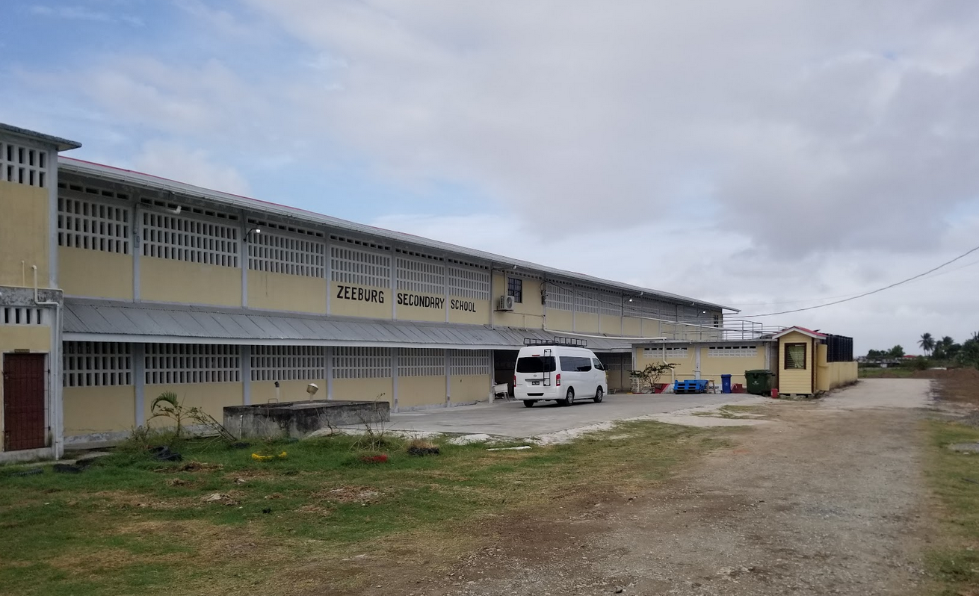
Figure 1: Frontal view of Zeeburg Secondary School

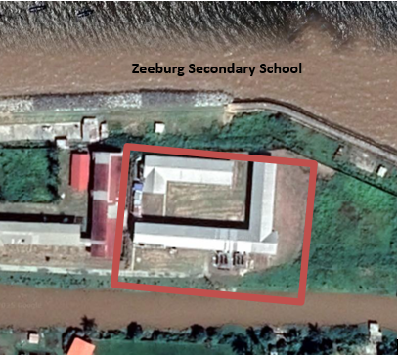
Figure 2: Location of Zeeburg Secondary School

Table 3: Demographics and Social Characteristics
Educational Institution | Location | Educational District | District Class Size 2020-2021 | Enrolment by District, sex 2020-2021 | Number of pupils per teacher by district 2020-2021 | Percentage Average Attendance by district 2019-2020
Zeeburg Secondary School | Zeeburg | Region 3 (Essequibo Islands West Demerara) | Total number of classes Primary Tops 29, General 220 | 6695 of which females are 3308 and males 3387 | 26 | General* 70%, Primary Tops** 67%
Source: MOE Statistical Digest 2020-2021
Note: Class size can range from 1-10 pupils at lowest and 71+ highest. For the period reported (2020-2021) class sizes have been mostly 1-10 up to 31-40 pupils.
**Primary tops are primary schools where the lower floor is primary, and the upper floor are secondary department of primary schools. Some primary tops offer a three-year programme geared to academic and pre-vocational programmes, while others provide a five-year programme.

This educational institution attends to students from Grade 7 through 11 usually ages 11 through 16. The age range for the teaching staff is 18-53. Its social baseline is characterized by indicators reflecting stakeholders and inclusion, livelihoods, occupational health and safety, and governance.

Table 4: Social Baseline Indicators
Stakeholders | Gender composition Zeeburg
Students | 613 of which 273 are males, and 339 females.
Teachers | 56
Parents/PTA | -
Ancillary Staff | -
Regional Executive Officer and Regional Education Officer | 2
Source: Interviews with stakeholders
Note: Was available for data collection

West Ruimveldt Primary School
The West Ruimveldt Primary School is located on the corner of Waterlily and Hunter Streets, Georgetown, Region 4. The total area of construction is 2550 m². It is a complex that includes two main buildings and accommodates six grade levels. The date of its construction is unknown. It is owned by the Ministry of Education. This school is surrounded by clusters of residential homes and small businesses that the serve students and the community.

In 2024, the total energy consumption was estimated at 24 173 kWh with a total cost of 3 595 814 GYD. When it comes to the CO₂ emissions, the total was 40 707 kgCO₂. If compliant with building codes, the energy consumption of the building is expected to reduce by 6,017 kWh with the new average consumption estimated at 55,105 kWh. Concurrently, CO₂ emissions are also decreased by 4,007 kgCO₂. Currently, there are no renewable energy system installations in the building.
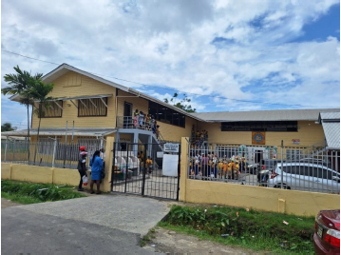
Figure 3: Frontal view of West Ruimveldt Primary School

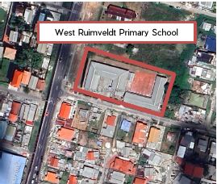
Figure 4: Location of West Ruimveldt Primary School

Table 5: Demographic and Social Characteristics
Educational Institution | Location | Educational District | District Class Size 2020-2021 | Enrolment by District, sex 2020-2021 | Number of pupils per teacher by district 2020-2021 | Percentage Average Attendance by district 2019-2020
West Ruimveldt Primary School | Georgetown | Georgetown | Total number of classes 546 | 12059 of which female 5939, and male 6120 | 20 | 81%
Source: MOE Statistical Digest 2020-2021
Note: Class size can range from 1-10 pupils at lowest and 71+ highest. For the period reported (2020-2021) class sizes have been mostly 1-10 up to 31-40 pupils.

The age range for students at West Ruimveldt primary school is 5+ to below 11 years old.

Table 6: Social Baseline Indicators
Stakeholders | Gender composition  West Ruimveldt
Students | 817 of which 425 are girls and 392 boys
Teachers | 43 of which 3 are males, and 40 females
Parents/PTA | -
Ancillary Staff | -
Regional Executive Officer and Regional Education Officer | 1
Source: Interviews with stakeholders
Note: - not available

Good Hope Secondary School
The Good Hope Secondary School is in Good Hope, Lusignan, East Coast Demerara, Guyana about 16 km east of Georgetown in Region 4 (Demerara-Mahaica), just off the main East Coast highway in the Good Hope Community. It sits within a development educational zone, surrounded primarily by homes and small businesses. It is a complex that includes eight buildings and accommodates multiple grade levels. The date of its construction is unknown. It is owned by the Ministry of Education.
Currently, there are no renewable energy installations in the buildings.
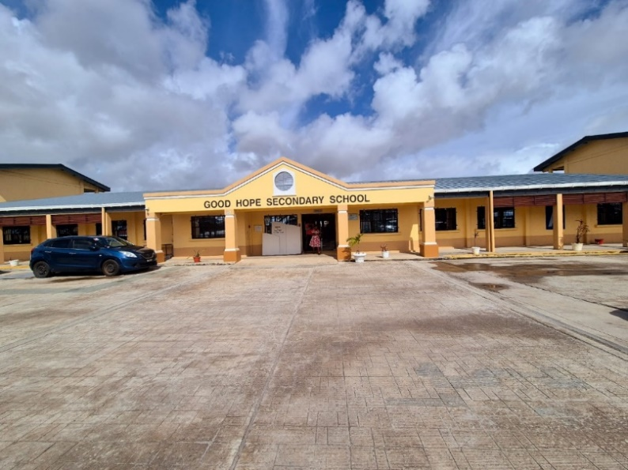
Figure 5: Frontal view of Good Hope Secondary School

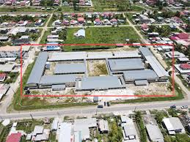
Figure 6: Location of Good Hope Secondary School

Table 7: Demographic and Social characteristics
Educational Institution | Location | Educational District | District Class Size 2020-2021 | Enrolment by District, sex 2020-2021 | Number of pupils per teacher by district 2020-2021 | Percentage Average Attendance by district 2019-2020
Good Hope Secondary School | East Coast Demerara | Region 4 (Demerara/Mahaica) | Total number of classes Primary Tops 47, General 338 | 10052 of which females are 4878 and males 5174 | 27 | General 76%, Primary Tops 38%
Source: MOE Statistical Digest 2020-2021
Note: Class size can range from 1-10 pupils at lowest and 71+ highest. For the period reported (2020-2021) class sizes have been mostly 1-10 up to 31-40 pupils.

Attendance at Good Hope Secondary School commences from Grade 7 through 11 and is usually for pupils ages 11 through 16. The age range for teaching staff is 23-50.

Table 8: Social Baseline Indicators
Stakeholders | Gender composition  Good Hope
Students | 753 of which 393 are males, and 360
Teachers | 61 of which 8 are males, and 53 females
Parents/PTA | -
Ancillary Staff | 11
Regional Executive Officer and Regional Education Officer | 2
Source: Interviews with stakeholders
Note: ⁻ not available

Yarrowkabra Secondary School
The Yarrowkabra Secondary School is in Yarrowkabra, Linden–Soesdyke Highway, which connects with the East Bank Public Road leading to Georgetown, Region 4 (Demerara-Mahaica), Guyana. It serves students from Yarrowkabra and nearby communities along the highway. The compound is surrounded immediately by other schools (nursery and primary) and in the distance, homes. It is a complex that includes multiple buildings and accommodates several grade levels, with a total of 35 classrooms. The date of its construction is September 2024. It is owned by the Ministry of Education.
Currently, there are no renewable energy system installations in the building.
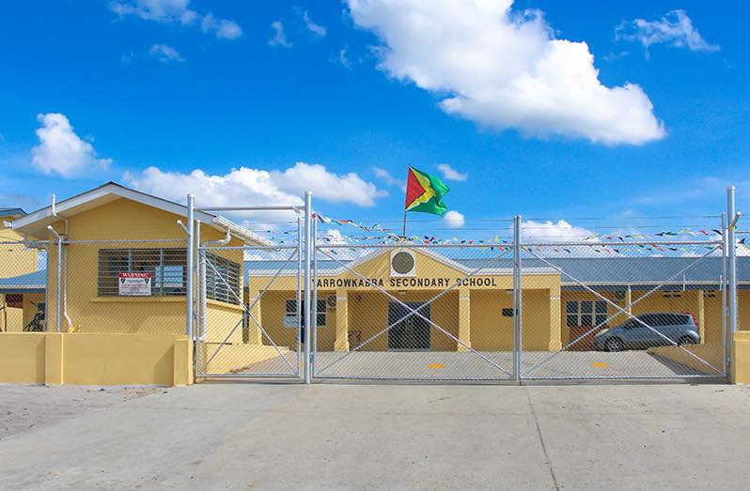
Figure 7: Frontal view of the Yarrowkabra Secondary School

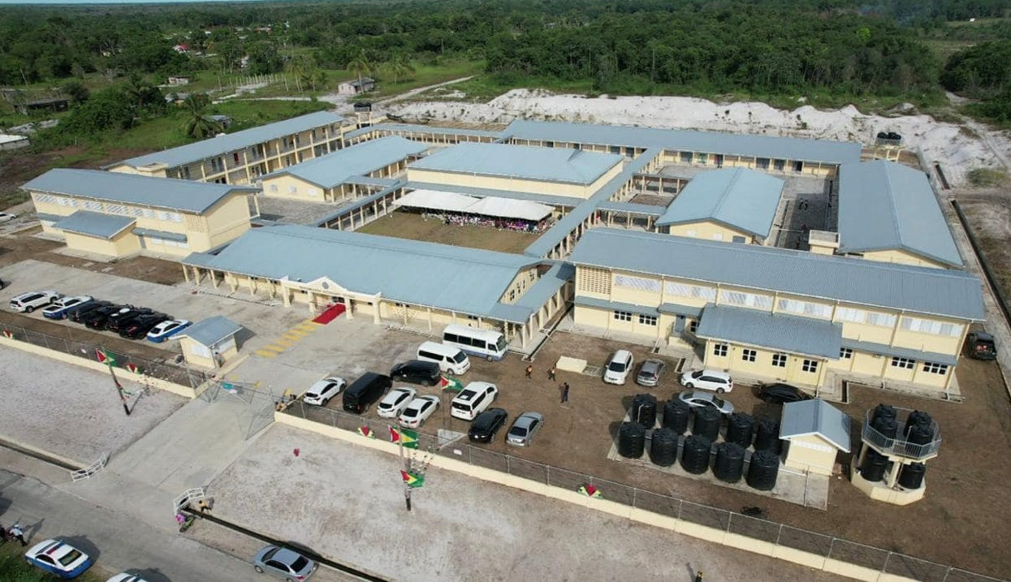
Figure 8: Location of Yarrowkabra Secondary School

Table 9: Demographic and Social Characteristics
Educational Institution | Location | Educational District | District Class Size 2020-2021 | Enrolment by District, sex 2020-2021 | Number of pupils per teacher by district 2020-2021 | Percentage Average Attendance by district 2019-2020
Yarrowkabra Secondary School | Linden-Soesdyke Highway | Region 4 (Demerara/Mahaica) | Total number of classes Primary Tops 47, General 338 | 10052 of which females are 4878 and males 5174 | 27 | General 76%, Primary Tops 38%
Source: MOE Statistical Digest 2020-2021
Note: Class size can range from 1-10 pupils at lowest and 71+ highest. For the period reported (2020-2021) class sizes have been mostly 1-10 up to 31-40 pupils.

Table 10: Social Baseline Indicators
Stakeholders | Gender composition  Yarrowkabra
Students | 1022, of which 532 females, and 490 males.
Teachers | 69 of which 9 are males, and 56 females
Parents/PTA | -
Ancillary Staff | 11
Regional Executive Officer and Regional Education Officer | 2
Source: Interviews with stakeholders
Note: - not available

Environmental and Social Management Plan
Identification and analysis of the environmental and social impacts were determined using the World Bank’s Environmental and Social Screening Form.
Table 11: Results of the Environmental and Social Screening of the educational institutions
Questions | Answer |  | Comments
Questions | Yes | No | Comments
ESS1 - Assessment and Management of Environmental and Social Risks and Impacts
Is the subproject likely to have significant adverse environmental impacts that are sensitive and unprecedented that trigger the ‘Ineligible Activities’ and exclusion? |  | No
Does the subproject involve renovation or rehabilitation of any small-scale infrastructure, such as windows, doors, ceilings, or shelters? | Yes |  | The EE retrofits will incorporate energy-efficient windows, shading, wall and roof insulation, cool surfaces, etc.
Is the site close to a water body? | Yes |  | Zeeburg Secondary School complex is located between the Atlantic Ocean and a water canal.
Will the subproject require clearing of vegetation? |  | No
Will the subproject be close to terrestrial/marine protected areas or sensitive area? |  | No
Will the subproject lead to sedimentation or soil erosion? |  | No
ESS2 - Labor and Working Conditions
Does the subproject involve uses of goods and equipment involving forced labor, child labor, or other harmful or exploitative forms of labor? |  | No | If “Yes”: Exclude from project.
Does the subproject involve recruitment of workforce including direct, contracted, primary supply, and/or community workers? | Yes |  | The implementation of civil works and associated activities will require specific expertise and skilled labour.
Do workers need PPE relative to the potential risks and hazards associated with their work? | Yes |  | PPE is mandatory for all civil works and related activities to ensure compliance with occupational health and safety standards and to minimize the risk of accidents, injuries, and exposure to hazardous conditions.
Is there a risk that women may be underpaid when compared to men when working on the project construction? |  | No
Does the project lead to any risks and impacts on, individuals or groups who, because of their particular circumstances, may be disadvantaged or vulnerable.⁴ |  | No
ESS3 - Resource Efficiency and Pollution Prevention and Management
Is the project likely to generate solid or liquid waste that could adversely impact soils, vegetation, rivers, streams, or groundwater? |  | No
Do any of the construction works involve the removal of asbestos or other hazardous materials related to construction works? |  | No
Are works likely to cause negative impacts to air and/or water quality? | Yes |  | The works are likely to cause temporary negative impacts to air quality due to the nature which includes drilling, excavation, mounting of solar panels, and associated civil works.
Does the activity rely on existing infrastructure that is inadequate to prevent environmental impacts? |  | No
Does the activity require civil works to support project activities? | Yes |  | The rooftop distributed solar PV systems will require minor civil works, including structural preparation of rooftops, installation and anchoring of mounting systems, drilling for fastenings, cable management, and minimal site preparation to ensure safe and secure installation.
Does the activity require the use of pesticides, mildewcides or other chemicals? |  | No
Is there a potential that the works will involve sites that are affected by issues related to mold? |  | No
Could the construction activities be a nuisance to other activities at the site, such as from dust, noise, construction vehicles etc.? | Yes |  | Construction activities could cause temporary nuisance to normal school activities.
ESS4 - Community Health and Safety
Is an influx of workers, from outside the community, expected? | Yes |  | The implementation of civil works and associated activities will require specific expertise and skilled labour.
Could the construction activities be a nuisance to community members, such as dust, noise, traffic etc.? | Yes |  | Construction activities could cause temporary nuisance to community members due to dust, noise, and increased traffic, as all school buildings are located within or near residential communities.
Could the construction activities disrupt the primary use of the site? | Yes |  | Construction activities could temporarily disrupt the primary use of the school buildings, as access to certain areas such as rooftops, classrooms, or common spaces may need to be restricted during installation.
ESS5 - Land Acquisition, Restrictions on Land Use and Involuntary Resettlement
Does the subproject involve involuntary land acquisition? |  | No
Does the subproject involve physical and/or economic displacement of people? |  | No
ESS8 - Cultural Heritage
Will the subproject involve any civil works that could involve demolition, renovations, or refurbishment to a historical or archaeological or culturally significant site or facility? |  | No

After screening, a risk assessment was carried out for each site. The magnitude of each risk/impact was assessed against the criteria for probability and severity. The probability of each risk/impact was rated “rare” (least probable) to “almost certain” (most probable) while the severity of each risk/impact was rated from “negligible” to (least severe) to catastrophic” (most severe),

Table 12: Risk Assessment Matrix
Probability of risk/impact | Severity of risk/impact
 | Low | Moderate | Substantial | High
High | Moderate | Substantial | High | High
Substantial | Moderate | Substantial | Substantial | High
Moderate | Low | Moderate | Substantial | Substantial
Low | Low | Low | Moderate | Substantial

Based upon these ratings, each risk/impact was assigned a rating of “low”, “moderate”, “substantial” or “high.”

Table 13: Identification of impacts on the Educational Institutions
E&S Component/Standard | Activities under the Project | Potential Impacts/Risk Rating
E&S Component/Standard | Activities under the Project | Environmental | Social | Risk Rating
Infrastructure Upgrade  (ESS 1,3) | Installation of energy efficiency measures like an external insulation layer on the roof, replacements of windows in conditioned rooms, ceiling mounted fans in classrooms and conditioned rooms, replacement of fluorescent tubes with LED lighting, installation of occupancy detection sensors in bathrooms and smart switches to control the electricity consumption in appliances and nighttime air conditioning shutdown  Installation of distributed PV systems on roofs like solar panels | These works will enhance the building’s thermal comfort, energy efficiency, and electrical systems, thereby contributing to an overall infrastructure upgrade.  Similarly, the installation of the DPV system will improve the building’s capacity to support renewable energy systems, thereby strengthening and modernizing the existing infrastructure without major reconstruction. | Minor disruption to normal school activities during installation works (noise, restricted access to classrooms), and potential safety risks to workers (falls from heights, electrical hazards). | Moderate
Air Quality  (ESS 3) | Roof work (drilling, cutting, anchoring)  Removal of windows, lighting, or insulation  Movement of packaging materials, insulation, and metal off-cuts  Trucks, forklifts, or carrying materials over unpaved areas | Dust and particulates released into the air can temporarily decrease local air quality, especially in and around classrooms or other occupied areas. | Inhalation of airborne particles may pose health risks to workers and building occupants (respiratory irritation, allergies, or exacerbation of asthma). | Moderate
Water Quality  (ESS 3) | Exposure/release of dust, debris, waste materials, small residues | Minor contamination from construction residues (dust, debris, or other materials) washed off during rain events, could enter drainage systems or surrounding soil and temporarily affect water quality. | Possible minor health or hygiene risks to nearby users if contaminated runoff reaches areas used by students, staff, or the surrounding community. | Low
Noise  (ESS 3) | Noise from power tools, hammering, and metal/concrete drilling  Minor noise from drilling, screwing, or mounting fixtures from the installation of fans, lighting, and sensors  Noise from cutting or adjusting mounting structures, fastening panels, and using hand or power tools during PV panel installation and wiring  Noise generated from demolition, dismantling, and handling materials, removal of old fixtures (windows, lighting, insulation)  Noise from movement of construction materials, pallets, and tools, and from forklifts or vehicles if used nearby, material handling and transport on-site  Occasional noise from electrical tools, testing equipment, or temporary generators (if used). | Temporary increase in noise levels from drilling, cutting, anchoring, and equipment installation (fans, insulation, PV panels, inverters), which may disrupt the surrounding acoustic environment. | Disturbance to students, teachers, and nearby community members due to elevated noise during school hours, which may interrupt learning activities and cause discomfort or stress if not properly scheduled or controlled. | Moderate
Soil  (ESS 1) | Temporary storage or staging of materials and equipment like pallets, insulation bundles, solar panels, or tools  Delivery and movement of heavy construction vehicles or equipment such as trucks or forklifts moving around the site  Spills of construction materials like adhesives, sealants, paint, or small amounts of metal off-cuts falling  Dust, debris, or residues from rooftop or indoor work that are washed onto ground-level areas | Temporary placement of materials, equipment, or scaffolding on ground-level areas may slightly compact the soil.  Drilling, cutting, or anchoring may produce dust or small residues that settle on nearby soil.  Small amounts of adhesives, sealants, paint, or metallic off-cuts could contaminate the soil if spilled or improperly disposed. | Health and safety risks if debris or spilled materials create tripping hazards.  Temporary inconvenience if outdoor areas normally used by students or staff are restricted during works. | Low
Land Use  (ESS 1) | Temporary placement of construction materials or equipment  Vehicle and equipment movement on site  Minor ground-level demolition or removal of old fixtures  Temporary containment or runoff management | Placement of materials, scaffolding, or equipment may temporarily restrict use of playgrounds, walkways, or parking areas.  Trucks or forklifts moving on site may cause minor soil compaction or temporary disturbance of surfaces.  Small areas cordoned off for fixture removal may temporarily limit access to land.  Temporary barriers or containment may occupy small ground areas. | Students and staff may need to use alternative areas for recreation, movement, or parking.  Areas occupied by materials or vehicles may create minor hazards if not properly cordoned.  Temporary changes in land use can slightly disrupt school routines or outdoor activities. | Moderate
Solid Waste  (ESS 1) | Removed windows, lighting, insulation, packaging waste (e.g., cardboard, pallets, fasteners) and possible metal off-cuts.  Periodic e-waste from sensors, lights, and switches. | Generation of waste from removed windows, lighting fixtures, insulation, packaging materials (cardboard, pallets, fasteners), and metal off-cuts, may increase solid waste volumes, if not properly managed or disposed. | Improperly managed waste could create safety hazards for students, staff, and workers, and cause nuisance or minor health risks to the school community.  Accumulation of waste may affect school cleanliness, hygiene, and visual appeal, potentially causing discomfort. | Moderate
Hazardous Waste  (ESS 3) | Removal and replacement of old fixtures like windows, doors, lighting fixtures, and insulation  Generation of waste like packaging, shipping materials, metal off-cuts and small construction debris  Replacement of electrical or electronic components like old switches and small electronic parts  General housekeeping and cleaning during installation can create dust, sweepings, and minor scrap materials | Disposal of small quantities of hazardous waste, such as fluorescent and mercury vapor bulbs, could release mercury or other toxic substances, potentially contaminating soil, water, or air if not handled correctly. | Improper handling or disposal could pose health risks to workers, students, and school staff, including exposure to mercury or other toxic substances. | Moderate
Biodiversity / Natural Habitat  (ESS 1,3) | No vegetation removal or habitat disturbance as all work is within existing structure and rooftop system avoids intrusion on natural areas. | No impact on biodiversity or natural habitats is expected, as all activities are confined to the existing school structure and rooftops, with no vegetation removal or intrusion into surrounding natural areas. | No direct social impacts are anticipated related to biodiversity or habitat, since local ecosystems are not affected by the works. | Low
Labour and Workforce  (ESS 2) | Interaction with contracted staff/project workers and children always require professional conduct,  Following worksite code of conduct, labour laws and regulations,  Hiring of project staff to work onsite  Worker’s awareness of Anti-discrimination and SEA/SH, and GRM |  | Labour employed by contractors may be required to interact with onsite school staff/project staff/ or school children that wander close to work activities. Risk exists, especially when contractors employ non-English-speaking workers who find it difficult to communicate and follow local labour regulation and worksite code of conduct. | Moderate to substantial
Community and Site Use  (ESS 4) | Construction and installation works  Material storage and equipment placement  Noise- and dust-generating activities  Vehicle movement and deliveries  Waste management activities  Engagement with school staff and local community | Construction activities (drilling, cutting, anchoring) may temporarily increase noise levels, affecting indoor and outdoor acoustic conditions.  Movement of materials, debris, and equipment can generate dust, affecting air quality in and around the school.  Storage of materials, scaffolding, and equipment may cover playgrounds, walkways, or parking areas, limiting access and minor surface disturbance.  Temporary storage of construction debris may affect site cleanliness if not properly managed. | Roof insulation, PV panel mounting, fan and lighting installation, wiring, and sensor setup may temporarily restrict access to certain areas of the school.  Temporary placement of scaffolding, tools, and materials may occupy playgrounds, corridors, or parking areas, affecting normal use.  Trucks and forklifts bringing materials may temporarily restrict access to school entrances or roads.  Nearby residents may experience temporary noise, dust, or minor traffic disruptions due to material deliveries or construction activities.  Lack of prior notice may cause frustration or misunderstandings among staff, students, or neighbours. | Substantial
Cultural and Historical Sites  (ESS 8) | No project activities are expected to affect cultural or historical heritage, as all works are confined to existing school structures and rooftops. | No environmental impacts are expected, as the project activities are not located near any known cultural or historical sites. | No social impacts related to cultural or historical heritage are anticipated. | Low
Health and Safety  (ESS 2,3) | Roof work (drilling, cutting, anchoring, panel mounting)  Electrical installation (wiring, inverter setup, lighting, sensors)  Handling and lifting of heavy materials and equipment  Removal of old fixtures (lighting, insulation, windows)  Dust- and noise-generating activities  Site movement and logistics | Minor dust generation as debris may settle on surrounding surfaces.  Potential for minor spills of lubricants or cleaning fluids if used.  Temporary movement on outdoor surfaces may slightly disturb soil.  Temporary air quality and acoustic impacts; no long-term environmental damage.  Minor disturbance to outdoor surfaces; no permanent land use change. | Risk of falls from heights  Risk of injury from tools or falling objects  Risk of electric shocks, burns, or short circuits  Risk of fire if not handled properly  Risk of strains and sprains  Risk of accidents from improper lifting or carrying  Risk of cuts, abrasions from broken materials  Risk of respiratory issues from dust inhalation  Hearing risks from prolonged exposure to loud noise  Risk of slips, trips, and falls  Risk of vehicle or equipment collisions | Substantial

Table 14: Mitigation and Monitoring Arrangements for Educational Institutions
Anticipated Risks and Impacts | Proposed Risk Mitigation Measures | Impact Mitigation
Anticipated Risks and Impacts | Proposed Risk Mitigation Measures | Timing/Frequency | Responsibility
AIR QUALITY
Health of children, air quality, and classroom comfort may be potentially affected by emission of dust particulates from roof work, drilling, and emissions from heavy vehicles | Wetting of work surfaces (e.g. roofs, walls, drilling areas) | Construction phase | Contractor – Site Supervisor
 | Use dust barriers and tarpaulins especially near classrooms | Before construction phase commences | Contractor
 | Schedule work during low occupancy periods e.g. after school hours, weekends, holidays | Planning phase and daily activity planning in construction phase | Contractor – Project Manager/School -Administrator
 | Routine cleaning of site and walkways to remove settled dust | Throughout construction phase | Contractor – Site Supervisor
 | Temporary relocation of vulnerable groups like younger children | As needed, if heavy dust is generated and sensitive groups are identified | School - Administrator
 | Communication of activities to staff and  students | Planning and construction phases | School - Administrator
 | Monitoring of particulate matter during peak activities near classroom and offices | Weekly | Contractor - ESHS Expert
WATER QUALITY
Health, school cleanliness and local drainage systems may be affected during rain events, as construction residues (e.g., dust, debris, paint chips, insulation fragments, packaging materials) may wash off into drains, surrounding grounds, or watercourses. | Cover stockpiles and materials with tarps | Before construction commences | Contractor - Site Supervisor
 | Install barriers around the perimeter of work areas | Before any roof work is done during the construction phase | Contractor
 | Minimize exposed areas by completing sections in phases | Planning phase | Contractor
 | Sweep work areas regularly to remove dust and light debris | Throughout construction phase | Contractor – Site Maintenance/School – Building Maintenance
 | Post rain inspection of work zones and drains for any signs of contamination | After any rainfall period during construction phase | Contractor – ESHS Expert
 | Temporary bins with lids for packaging and materials | During construction phase | Contractor
 | Monitor water quality after rain or weekly downstream of runoff area | During construction phase | Contractor – ESHS Expert
NOISE
Disruptions of classes discomfort to students and staff or pose health risks with prolonged exposure from temporary increase in noise levels due to construction activities such as installation of fans, insulation, solar panels, drilling, anchoring, and inverter setup. | Schedule noisy activities outside teaching hours (early mornings, weekends, holidays) | Planning phase and construction planning and daily scheduling | Contractor/School -Administrator and Building Maintenance
 | Notify staff and students in advance about planned noisy activities | 24-48 hours prior to activities | Contractor/School -Administrator
 | Use low-noise equipment and tools where feasible | Planning and construction phases | Contractor
 | Relocate sensitive activities like exams away from noise | Planning and construction phases | School - Administrator
 | Limit duration of high-noise tasks per zone | Planning phase | Contractor - Site Manager
 | Worker awareness training on noise protocols and student sensitivity | Planning phase | Contractor – ESHS Expert
 | Maintain equipment to avoid excessive noise releases | Weekly during construction | Contractor
 | Monitor noise levels (dB) outside classrooms and offices near construction | Daily and/or during peak activity | Contractor – ESHS Expert
SOLID WASTE
Environmental pollution, safety hazards, and unpleasant sights from solid waste generated during construction and retrofitting activities, including old windows, lighting fixtures, insulation material, packaging (plastic, foam, cardboard), metal cut-offs, and eventual electronic waste (inverters, batteries, panels). | Handle removed windows and glass frames with care, segregate from general waste, reuse frames if possible or store for safe disposal by NDC approved contractor | Construction phase | Contractor, NDC
 | Separate fluorescent from Hg bulbs and temporarily store in labelled boxes, avoid breakage until final disposal by certified hazardous waste handler / EPA-approved disposal facility | Construction phase | Contractor, NDC
 | Flatten cardboards, reduce single use packaging before final disposal by approved NDC contractor | Construction phase | Contractor, NDC
 | Remove sharp edges of any mounting brackets | Construction phase | Contractor
 | Store e-waste in dry secure area until disposal is arranged by certified hazardous waste handler / EPA-approved disposal facility | During operation and maintenance | School - Building Maintenance, EPA
Improper handling/ disposal of FL bulbs can lead to mercury contamination of air, soil, and water which may risk student and staff health through direct exposure or accidental breakage. | Careful removal of FL bulbs to avoid breakage | As FL bulbs are removed during construction phase | Contractor - Electrical Technician
 | Use of sealed, labelled storage containers for used bulbs (e.g., “Hazardous - Used FL Bulbs”) in dry, ventilated area away from student access in school building until final disposal by certified hazardous waste handler / EPA-approved disposal facility | Immediately after removal during construction phase/  Daily visual check during construction phase | Contractor – Site Supervisor
 | Separate hazardous waste stream from general construction waste | Throughout construction phase | Contractor – ESHS Expert
 | No on-site crushing or breaking of bulbs | Continuous through construction phase | Contractor – ESHS Expert
 | Train workers on handling, spill response and use of PPE | One time, refresh as needed during construction phase | Contractor – ESHS Expert
 | Coordinate with certified hazardous waste handler / EPA-approved disposal facility  - Notify the EPA Guyana of the volume and type of hazardous waste generated.  - Engage an EPA-approved contractor or recycler for final disposal.  - Keep a register of hazardous waste movement for auditing purposes. | During the planning and construction phases | Contractor/School - Building Maintenance, EPA, NDC and EPA approved Contractor for waste disposal
 | Monitor the number of FL bulbs removed as it occurs, the storage condition and access weekly and any incidents of bulb breakage immediately | Planning and construction phases | Contractor – ESHS Expert
TRAFFIC/VEHICULAR MOVEMENT
Disruption to traffic within and around the school during material deliveries.  Safety risks to students and staff due to movement of trucks and construction vehicles.  Temporary obstruction of school access or parking areas. | Schedule material deliveries outside of peak school hours to minimize traffic disruption.  Notify nearby residents, businesses, and road users in advance about the expected increase in construction and heavy vehicle traffic to minimize inconvenience and ensure public safety.  Use designated areas within the school premises, such as service yards or parking lots, for temporary parking of trucks and storage of materials.  Coordinate with school management to communicate delivery times and access routes.  Ensure vehicles follow safe speed limits within school grounds and implement traffic marshals if necessary. | During planning and construction phases | Contractor/School – Building Maintenance
Improper or unsafe storage of construction materials on-site. | Clearly mark and cordon off material storage areas to ensure safe movement of students and staff. | During planning and construction phases | Contractor/School – Building Maintenance
SOCIAL
Disruptions | Schedule work during holidays or on weekends | Construction phase /daily | Contractor/School – Administrator
Disruptions | Communicate benefits to staff and teacher | Operation phase/monthly | School and PIU
Disruptions | Awareness and enforce code of conduct and child protection | Prior to construction/daily | Contractor
Health and safety | Signage, no access zone for students, Awareness for staff and students; | Construction phase/daily | Contractor/School – Administrator
Gender Inclusion | Ensure safety in common areas; consult with female staff members | Design and installation phases/weekly | School and PIU
Labour issues (Working conditions, code of conduct, SEA/SH, and anti-discrimination policies) | Contracted employees should sign contracts that are clear on LMP policies including workers’ code of conduct, conditions, SEA/SH, and awareness of workers’ GRM | Implementation phase /monthly and immediately once there is a change in staff | Contractor and PIU

Implementation Arrangements and Reporting
Project Implementing Unit (PIU)
An established Project Implementing Unit (PIU) within the Guyana Energy Agency (GEA) will be responsible for the implementation and management of the activities under the CEGEB Project. The Project Manager will report to the Chief Executive Office of the GEA. Roles of the PIU include but are not limited to:
- Raising awareness about the Project;
- Planning and managing the implementation of the Project;
- Subprojects screening to ensure eligibility criteria are met and developing the subproject pipeline;
- Supervision, reviewal and approval of all energy audits, designs and renovations;
- Conducting the procurement of country specific activities;
- Participating in the pooled procurement activities led by the OECSC PIU
- Project financial management;
- Compliance with environmental and social requirements, and fiduciary requirements;
- Ensuring coordination between the National Project Implementation Unit and the Regional Project Implementation Unit;
- Project monitoring and reporting to the World Bank and the Ministry of Finance, Guyana

The Environmental and Social (E&S) aspects will be managed by the Environmental and Social Officer. As part of the PIU, they will be responsible for ensuring the implementation of each investment according to the site-specific documents developed, such as ESMPs, OHSPs, and sub-project management plans. The E&S Officer will monitor the correct implementation of the E&S measures as part of periodic project monitoring visits while works are taking place at the sub-project site. The PIU will comprise existing staff from the GEA and new hires as needed by the Project, which will include the following roles:

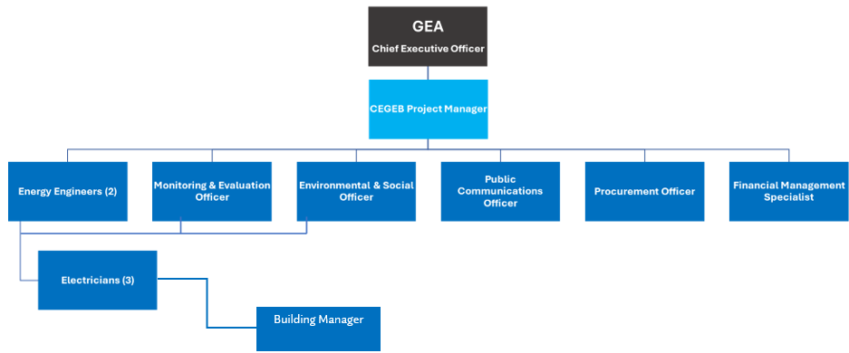
Figure 9: Organisational Structure of the Project Implementing Unit

KEY
Project Manager (PM) | Environmental and Social Officer (ESO)
Energy Engineers (EEn) x 2 | Public Communications Officer (PCO)
Electricians (E) x 3 | Procurement Officer (PO)
Monitoring and Evaluation Officer (MEO) | Financial Management Specialist (FMS)

Contractor
- The Contractor will comply with all the project’s E&S risk management plans and procedures, which are integrated into the bidding documents, including ESMPs, Environmental and Social Consultation Plans, Labour Management Procedures, sub-management plans and national legislation. The contractor will ensure that construction-related grievances are received and addressed to the Grievance coordinator and resolve the grievances that could be resolved on-site. The contractor immediately notifies the E&S Officer about any significant incident (accidents, spills, fatalities, etc.) that may have significant adverse effects on the environment, community, the public or workers.
- The Supervision and Commissioning Consultant will oversee the daily implementation and monitoring of environmental, social and OHS mitigation measures, and report the progress of the sub-projects to the Guyana PIU E&S Officer through Monthly Monitoring Reports.
- The contractor ESHS Expert will provide input to the S&C Consultant for the preparation of the Monthly Monitoring Report on the ESHS performance. They will also disseminate and create awareness within the workforce regarding E&S risk management. The ESHS Expert ensures the stakeholders are informed and consulted before the commencement of any construction works and ensures continuous stakeholder engagement throughout the life of the Project. The contractor ESHS Expert prepares method statements for implementing E&S mitigation instruments and monitors site activities on a regular basis as defined in ESMP in compliance with E&S risk management instruments prepared for sub-projects.

Occupational Health and Safety and Governance
Occupational Health and safety concerns being addressed are important to mitigating the potential for time and other losses from implementing the Project. Occupancy schedules (in terms of main operating hours and the number of onsite users) are crucial discernment to comprehend and respond to EEMs. This guides the training and orientation needed for operations and sustainability of the installed capacity by the building manager.

In addition to the Occupational Health and Safety Act 1997, there exists a functional OHS policy (Government of Guyana MOE National Policy for Schools’ Infrastructure Development and Maintenance 2023) for all the educational institutions under consideration. Building works at each educational institution are undertaken within the purview of the respective region/district authority. At the regional/district level there is the Regional Education Officer (REDO) (and for Georgetown, the Principal Education Officer) responsible for education matters in that district. They communicate to the building manager (based in the regional authority office) the works required to be undertaken at a school/educational institution. Educational building maintenance in a region is the responsibility of the Regional Executive Officer (REO), under the Ministry of Local Government and Regional Development, see Figure 35 below. Building managers, report to the REO and undertake the execute maintenance and operations of the schools in a specific region usually referred to as regional engineer or superintendent of works.

Once the solar PV are installed, and the EEMs are completed and handed over to the educational institution, its maintenance would be the responsibility of the Regional Executive Office,

Figure 10: Institutional Capacity Structure for Maintenance and Operations

Such governance structure requires that both the regional executive officer and the regional education officer (Principal Education Officer for Georgetown) be informed and kept appraised as important stakeholders for implementation and sustainability.

School Management / PTA / Community Stakeholders
The roles and responsibilities include:
- Support in communicating schedules, restrictions, and safety measures to students, teachers, and parents.
- Participate in orientation sessions and grievance redress mechanisms.
- Report concerns or grievances to the contractor or PMU for resolution.

Reporting Framework
Daily | Contractor’s ESHS Expert maintains site logs (incidents, waste management, PPE use, grievances received).
Weekly | Toolbox talks and short updates on compliance (by Contractor).
Monthly | Contractor submits a detailed ESMP compliance report to the Supervising Engineer/PIU.
Monthly | Supervising Engineer consolidates monitoring findings and submits to the PIU.
Semi-Annual | PIU prepares E&S performance reports for the funding agency and regulatory authorities.
Ad hoc / Immediate | Incident reports (accidents, environmental spills, community complaints) must be submitted within 24 hours.

Institutional Strengthening and Capacity Building
Institutional strengthening and staffing are important to implementation as it ensures that appropriate skills and systems are in place to manage risks, comply with regulations, and sustain the benefits of the project. Considering this, the following aspects are proposed for consideration:
- School maintenance manager/building manager is required for management of the DPV system and the EEMs and any new AC systems. This can be facilitated through skill upgrade of an existing staff or hiring of a technician.
- Partnership with EPA is essential for the support of hazardous waste management and disposal.
- Health, Safety and Environmental Officer appointment from the Contractor is recommended to ensure contractor compliance and safe work zones.

Capacity development and training allow key stakeholders to identify, mitigate, and monitor environmental and social impacts. It promotes safe and compliant handling of hazardous and non-hazardous waste and ensures all parties understand their roles in safeguarding student and staff welfare during project execution. It also maintains longevity as institutional capacity is maintained for the energy systems after installation.
Table 15: Training Plan
Training Topic / Activity | Target Group | Provider (Responsibility) | Timing / Frequency | Number of Trainings
Environmental and Social  Management | Contractor’s workforce | Contractor’s ESHS Expert | Initial (before works commence); refresher monthly or as needed | 4-6
Occupational Health and Safety (OHS) | All site workers (including subcontractors) | Contractor’s ESHS Expert; Supervision Engineer (oversight) | Initial induction before mobilization; monthly toolbox talks; refresher quarterly | Ongoing (toolbox talks); 2 formal sessions
PPE Use and Safe Rooftop Work | Installation teams, site workers | Contractor’s ESHS Expert | Initial (before rooftop works); refresher mid-project | 2
Hazardous Materials and Waste Handling | Relevant workers (handling wiring, batteries, lubricants, waste) | Contractor’s ESHS Expert | Initial training; refresher mid-project | 2
Traffic and Vehicle Management | Drivers, logistics staff, site workers | Contractor | Initial; refresher if incidents occur | 1–2
Code of Conduct Orientation | All contractor and subcontractor workers | Contractor’s HR Officer | Initial (before engagement); refresher monthly on renewal of contracts | 2
Gender Sensitivity & Child Protection | All site workers; Contractor’s staff | Contractor’s HR Officer | Initial (before works start); refresher mid-project | 2
Awareness for School Community (Orientation) | Teachers, students, PTA / School Management Committee, parents | Contractor with support from Project Implementing Unit and School Administration | Before commencement of works; follow-up mid-project | 2

Grievance Redress Mechanism
A Grievance Redress Mechanism (GRM) should be in place to allow affected stakeholders (including for workers) to voice concerns and seek timely resolution, based on risks including those unintended.

The critical steps involved in the GRM is noted in table 7 below, see annex 1 for forms:

Table 7: Compulsory steps for Grievance Redress Mechanism
STEP | DESCRIPTION | ROLES AND RESPONSIBILITY
SUBMISSION | Complaint submitted in writing or verbally to or by stakeholder | Affected stakeholder
RECORDING | Logged in a GRM register | Focal Point
ASSESSMENT | Assessed by school within 7 days. In cases of workers’ GRM assessed within 7 days as well | Grievance Redress Committee (GRC)
RESOLUTION | Provided within 10 days | GRC relate to Focal Point
APPEAL | If unresolved referred to local authority or PIU | Local Authority

Complaints will be submitted to the PIU as the final or last resort and would be the responsibility of the Social and Environmental Officer. At each site the forms should be available via the Head of the educational institution and his/her office. The phone number, email, and envelope (alternative to the drop box) should be available for those, especially workers, who are desirous of logging a complaint to the E&s officer of the PIU, but do not want to engage with the educational institution on site. They may also attend consultation meetings to raise concerns directly.

Stakeholder Engagement
As noted in the ESMF 2024 the SEP defines a program for stakeholder engagement, including public information disclosure and consultations throughout the entire project cycle.

It is already recommended by the ESMF 2024 that start up consultations should “...discuss the Project’s objectives and activities, the grievance management process, and specific interventions planned for each site and potential impacts and risks related to the proposed project activities….”.

Stakeholder Identification and Analysis
For the CEGEB project the identification of core stakeholders, interests and potential concerns (see Table 10), at minimum, is compulsory for the monitoring and reporting process to meet the required standards of mitigating social risks and being responsive to stakeholders.

Table 19: Stakeholders’, Interests, and Needs
STAKEHOLDER GROUP/AFFECTED PARTIES | INTEREST IN THE PROJECT | POTENTIAL CONCERNS / NEEDS
STUDENTS | Improved learning environment; comfortable atmosphere for classes | Safety during installation; noise disruption
TEACHERS & ANCILLARY STAFF | Better working conditions; classroom lighting | Safety, consultation on timing
PARENTS / PTA | Welfare of students; school costs | Disruption, safety
SCHOOL ADMINISTRATION | Project coordination; facility improvement | Implementation support, schedule adherence
NEARBY SCHOOL WITH SAME ACCESS ENTRANCE | Impact on traversing activities the entrance pathway | Access, noise, customer disruption
CONTRACTOR / INSTALLERS | Implementation of technical work | Access, scheduling with school calendar
WOMEN’S / VULNERABLE GROUPS | Equitable participation | Safety, participation in meetings or awareness platforms/tools
REGIONAL EXECUTIVE OFFICER AND REGIONAL EDUCATION OFFICER | Responsible for maintenance and operations of any additional capacity added to Zeeburg Secondary School | What EEM and DPV require to be maintained and its operation.

Engagement Program
Site visits and virtual interactions have constituted stakeholder engagement thus far. Going forward
The method of engagement should expand in the following manner - focus group for general issues (either by sector, region, etc.), and key informant to be responsive to sensitive issues (example GBV) and vulnerable groups (example women). Bi-monthly meets should be sufficient, unless a need arises from the GRM which requires 7 days for review and 10 days for resolution, in an emergency.

Sub project Site type, name, and location | Stakeholder (s) | Method of engagement | Activities (including topic or theme covered) | Frequency | Responsible Party

Monitoring and Evaluation of Engagement
As part of the stakeholders’ engagement process some core indicators must be captured to monitor and evaluate. The important characteristics of monitoring to be captured from stakeholders’ engagement are:
- Number of stakeholders consulted (Meeting attendance sheets per period)
- Diversity of participants (e.g., gender, age, designation, contact information – Participant records per period),
- Issues raised and addressed (Feedback log / GRM log)

Information Disclosure Plan
Information sharing is most important for disclosure, especially in compulsory awareness. The type of information, when, how, and in what format will vary. However, principally information can be shared for the CEBEG as follows:
- Project summary and timeline can be shared via flyers, notice boards, meetings and virtually
- Safety guidelines via posters, signage, building department heads, etc in an understandable language (graphics and creole English). GRM contact information are to be shared similarly.

It is important to consider the existing information sharing channels within the educational institutions under consideration, and the local government network to avoid duplication and save resources.

Cost
The costing table was developed by identifying all Environmental and Social (E&S) mitigation and monitoring measures proposed in the ESMP. For each ESMP activity (e.g. waste management, dust suppression, worker safety training, community engagement, PPE provision, SEA/SH awareness), the following were specified:
- Type and scope of the activity
- Frequency or duration of the activity

Integration into the Bidding Documents
These costs are not listed as separate provisional sums in the Bill of Quantities. Instead, they are integrated into the contractor’s unit rates for related construction activities, as required by good practice and procurement rules.
- The bidding documents will:
  - Include the ESMP as part of the tender package.
  - Clearly state that all costs to implement E&S mitigation and monitoring measures must be included in the contractor’s prices for the respective works.
This ensures that E&S compliance is mainstreamed into the project implementation, and that contractors allocate adequate resources (personnel, materials, and budget) to carry out the required mitigation and monitoring activities.

Table 20: Cost Estimates for all four institutions
Activity / Measure | Frequency | Responsible Party | Costing Approach | Estimated Cost (USD)
Provision of PPE (helmets, gloves, harnesses, safety boots, reflective vests) | Daily, throughout works | Contractor | Included in unit costs (site safety) | –
Toolbox talks / OHS refresher briefings | Weekly | Contractor | Included in contractor’s staffing cost | –
Formal OHS & Safeguards Training | Initial + refresher mid-project | Contractor | Included in contractor’s cost | –
Code of Conduct orientation | Initial (before works) + refresher annually | Contractor HR / Safeguard Specialist | Included in contractor’s mobilization costs | –
Waste collection and disposal (general + hazardous) | Weekly / as needed | Contractor | Included in site operations costs | –
Dust and noise control (e.g., wetting surfaces, noise barriers if needed) | Daily during works | Contractor | Included in construction methods | –
Traffic and vehicle management (scheduling, safe parking, marshals) | Daily during deliveries | Contractor | Included in logistics costs | –
Grievance redress mechanism (logbook, hotline, community liaison) | Continuous | Contractor / PMU Safeguard Officer | Included in contractor’s management cost | –
Orientation for teachers, students, and members of the community | Twice (before works + mid-project) | Contractor/PIU/ | Small separate allocation | $2,000
Contingency for unplanned E&S measures | As needed | Contractor | Separate allocation | $3,000
Total Estimated E&S Budget | – | – | – | $7,000

Annex

Grievance Redress Forms

Table 16: Grievance Submission Form
Date received: | Date: (dd-mm-yyyy)
Grievant Name |  | □ Please keep my name confidential
Other Information:

Contact Information: | Phone:  Email address:  Address:  (Please indicate the preferred method of communication)
Details of grievance:  (Who, what, when, where) | □ One-time incident/complaint  □ Happened more than once (indicate how many times): ___________  □ Ongoing (a currently existing problem)  Details of the case:  When did the case occur?  Provide the location relating to the case/complaint.  List the persons involved in the case.  What are the effects of the ensuing situation?
How would you like to see issue resolved?
Attachments to the grievance:  (e.g., pictures, reports etc.) | List here:

_____________________________________ ______________________________
Grievant Signature (if applicable) Date (DD/MM/YYYY)
_____________________________________ ______________________________
Signature-Project personnel (to confirm receipt only) Date (DD/MM/YYYY)

For PIU use only:
Grievance Category:
□ Power outages
□ Waste Management
□ Construction Quality/Equipment
□ Traffic/Road Access
□ Problem with staff (Project/Contractor/Sub-project site)
□ Consultations
□ Trainings
□Other (specify) ______________________________________________________
Grievance No: ______________________
Priority Level: Low/Medium/High________________________________________
Grievance Owner/ Department: ________________________________________

Table 17: Grievance Management Registration and Monitoring Sheet
No. | Name of  Grievant | Date  Received | Grievance uptake channel used | Location/ sub-project site, if applicable | Gender of grievant/ | Grievance category | Grievance Description | Further  Intervention? | Action(s)  taken by PIU | Resolution Accepted/ Not  Accepted  Y/N | Date | Grievant Satisfaction score  (1: Highly Unsatisfied-5: Highly Satisfied)

Table 18: Grievance Disclosure/Release Form (Result Of Grievance Management)
Grievance No:
Name of Grievant:
Date Filed:
Summary of Grievance:

Summary of Resolution:
Satisfaction Score of Grievant
(1: highly unsatisfied – 5: highly satisfied)
Date of grievance resolution (DD/MM/YYYY):

Signature of Grievant in acceptance of the suggested grievance resolution: | Name:
ID type and number: | Date (DD/MM/YYYY):

Signature of Social Development Specialist | Signature of PIU Head:
Name:  Place:  Date (DD/MM/YYYY): | Name:  Place:  Date (DD/MM/YYYY):

