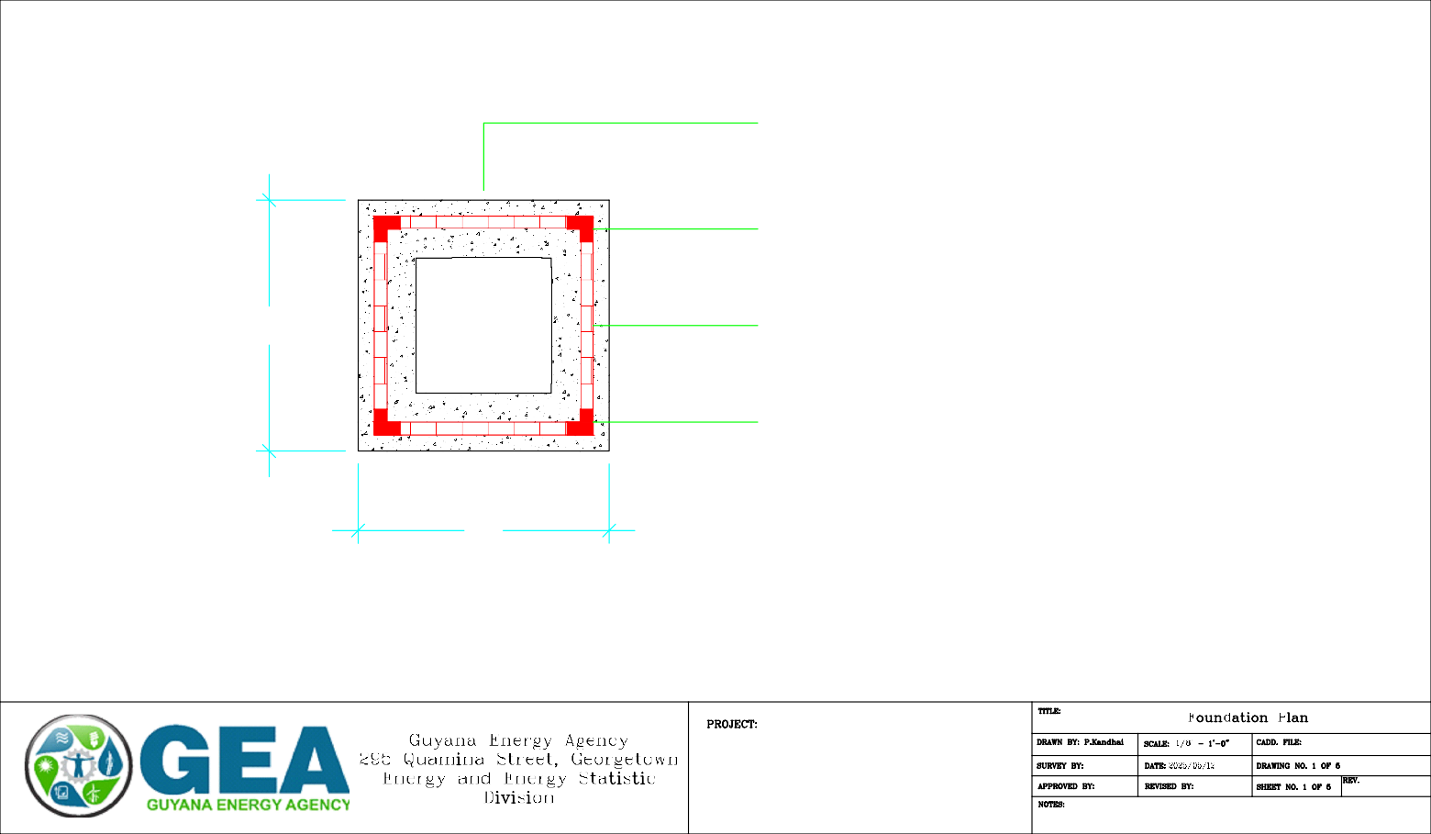

18" STRIP FOUNDATION (1:2:3 MIX) WITH 3 NR. 1/2" MAIN BARS
3/8" STIRRUP @ 6" C/C

4" HCB TIED AT CORNER AND CAVITY FILLED WITH 1 NR. 3/8"" MAIN BAR AS STARTER

4" CAVITY FILLED (1:2 MIX) HCB KURB SEE CROSS SECTION FOR DETAILS
6'-6"

4" HCB TIED
WITH 1 NR. 3/8"" MAIN BARS AS STARTER

6'-6"

FOUNDATION PLAN

Battery/ Inverter Facility

4" THICK GF SLAB (1:2:3 MIX)

3/8" CORRUGATED BARS TIED 8" C/C IN BOTH DIRECTIONS DAMP PROOF MEMBRANE
4"

4" HCB FOR KURB - CAVITY FILLED (1:2 MIX)
3/8" DIAMETER STARTER BARS @ 16" C/C - LENGTH = 4 - TIED ONTO MAT FDN.

WELL COMPACTED WHITE SAND - 2' - HEIGHT OF KURB MAY VARY
2'

EXISTING GROUND LEVEL

1/2" DIAMETER MAIN BARS
2"
6"
2" COVER TO SIDE, MAT STEEL FDN.
3/8" DIAMETER STIRRUP @ 6" C/C
2" THICK BLINDING (1:3)

6" THICK WC SAND-FILL - THICKNESS MAY VARY
6"

1'-6"
FOUNDATION CROSS SECTION - HEIGHT OF KURB MAY VARY

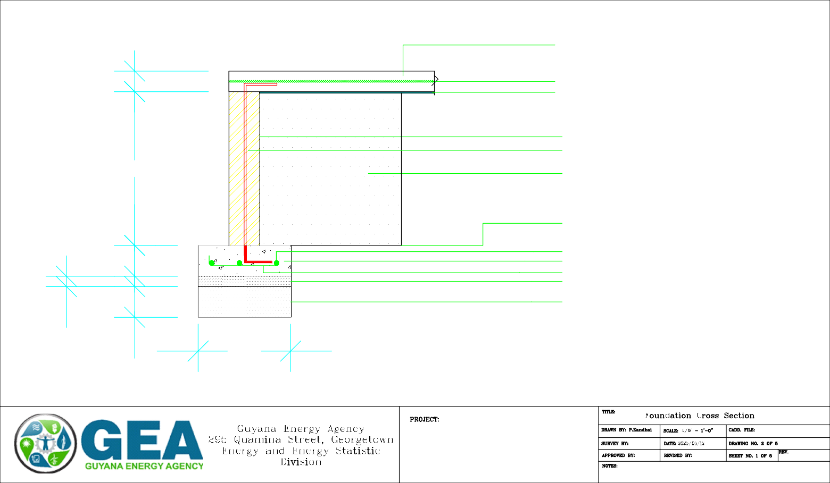

Battery /Inverter Facility

7'-8"
7'-8"

5'-8"
4"
4"

- COMBINER
3'
4"
BOX

6"
6"
PANEL
INVERTER
BATTERY
TRUNKING
- RACK B
5'-8"
8'-7"
DISCONNEIT

TRUNKING
6"
3'-1"
8'-8"

TRUNKING

8"

BATTERY RACK
INVERTER
1'
6'
8'-8"
3'-1"
BATTERY RACK

STAIR A
4"
2'
7"
4"
2'
2'
4"

PLAN

5'-8"

2'-8"

5'-8"

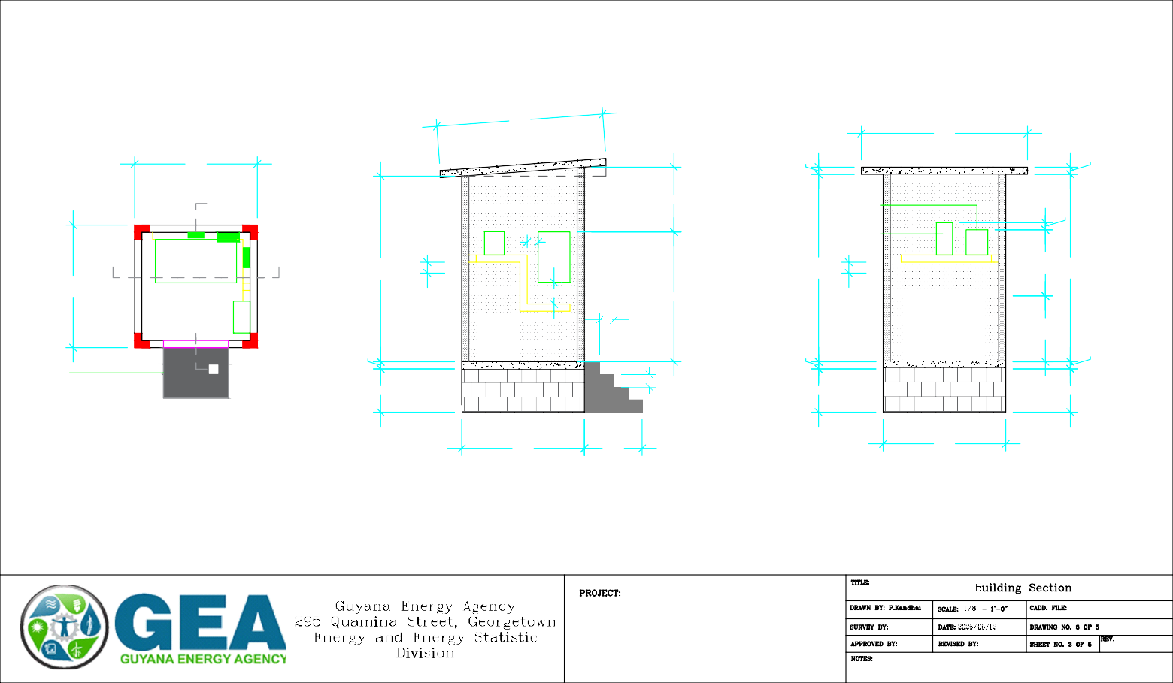
SECTION A-A SECTION B-B

Battery/ Inverter Facility

7'-8"

1'

4" THICK ROOF SLAB (1:2:3 MIX) WITH 3/8" CORRUGATED BARS TIED 8" APART IN BOTH DIRECTION

7'-8"

1'

2 ROW ENV. VENT BLOCKS COVERED WITH INSECT MESH

1 ROW ENV. VENT BLOCKS COVERED WITH INSECT MESH
9'
4'-4"
8'-7"
8'-7"
4'-4"
9'
8" 8"
7"
1'-6"
4"
4"
1'-6"
7"

2'-8"
2'
2'
5'-8"
5'-8"
2'-8"

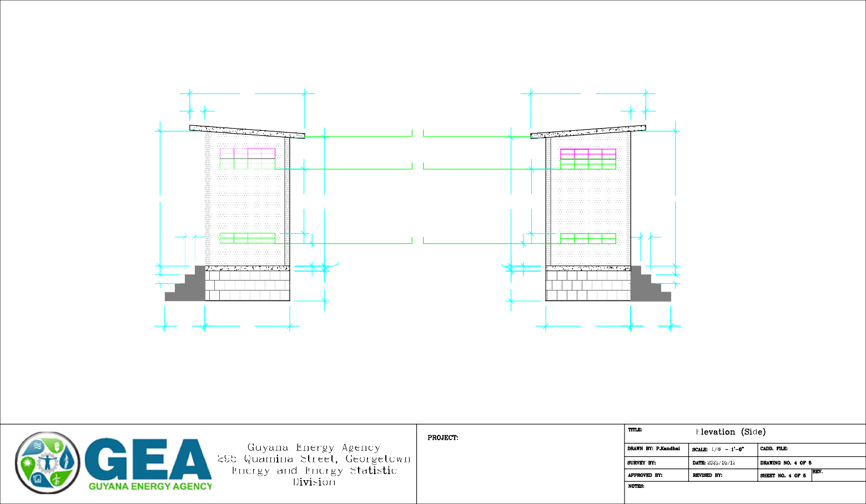
ELEVATION (SIDE) ELEVATION (SIDE)

Battery/Inverter Facility

7'-8"

4" THICK ROOF SLAB (1:2:3 MIX) WITH 3/8" CORRUGATED BARS TIED 8" APART IN BOTH DIRECTION

7'-8"
4"
4"

4" THICK ROOF SLAB (1:2:3 MIX) WITH 3/8" CORRUGATED BARS TIED 8" APART IN BOTH DIRECTION

EXTERNAL WALL WITH 4" HCB WITH 1/2" RENDERING
8'-8"
4" HCB TIED AND CAVITY FILLED (ENDS) EXTERNAL DOOR - OPEN TOWARDS OUTSIDE
EXTERNAL WALL WITH 4" HCB WITH 1/2" RENDERING
4" HCB TIED AND CAVITY FILLED (ENDS)
8'-3"

4" (1:2:3 MIX) THICK GF SLAB WITH SPC FINISH 4" (1:2:3 MIX) THICK GF SLAB WITH SPC FINISH
4"
2'
4"
2'

5'-8"
5'-8"

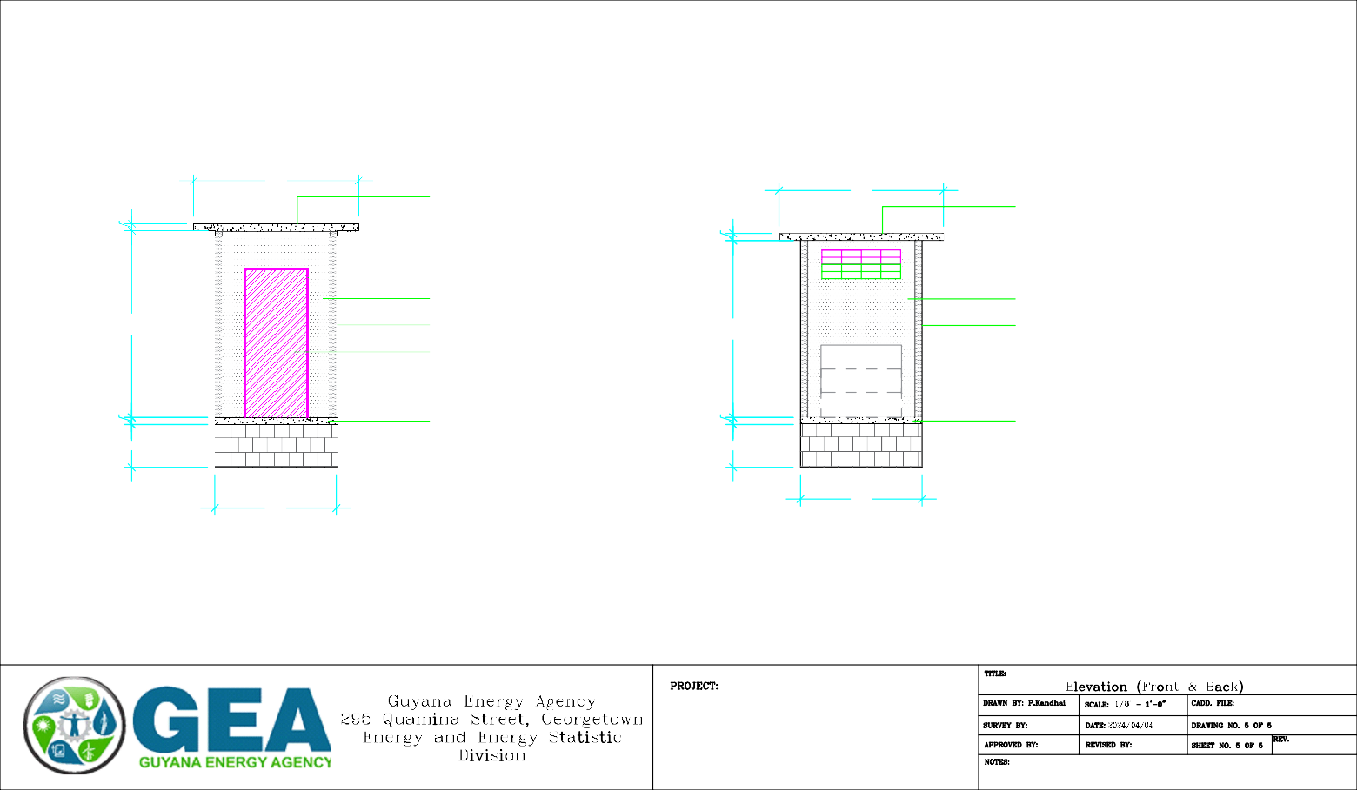
ELEVATION (FRONT) ELEVATION (BACK)

Battery/Inverter Facility

